**Technical Specification Document**

**Project Name : Maverick MMP2**

**Date : May 6th 2025**

|  |  |
| --- | --- |
| **Service** | **PIC** |
| **[MVRK] MMP2 R4 - Migrasi quota-id ke Web Method ISL (WebMethod)** | **Rahmat** |
| **[MVRK] MMP2 R4 - Migrasi quota-sid-id ke Web Method ISL (WebMethod)** |
| **[MVRK] MMP2 R4 - Migrasi seri-redeem-id ke Web Method ISL (WebMethod)** | **Randi** |

**1. Introduction**

**1.1 Purpose**

The purpose of this service is to act as middleware that bridges communication between the channel and the backend system, with the primary function of securely and systematically facilitating the addition of investment accounts.

**1.2 Scope**

This service will be implemented in the WMS feature for SBN Valas and Mutual Funds, and will connect only to the Avaloq system or the Kemenkeu system.

* 1. **Impact Analysis**

Wondr API Management should re-route to all new services.

**2. System Architecture**

**2.1 Overview**

This service is to act as a middleware that bridges communication between the Wondr channel and the Avaloq or Kemenkeu system, with the primary function of securely and systematically facilitating the addition of investment accounts.

**2.2 Flow Diagram**

**2.2.1 Add Investor Account (ISL Maverick)**

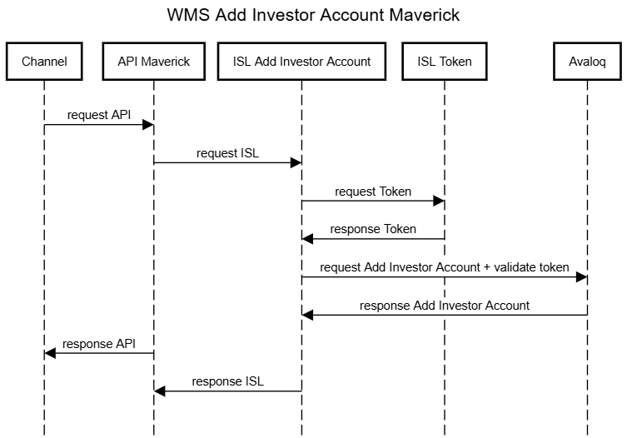

**2.2.2 Inquiry RSP Trasactions (ISL Maverick)**

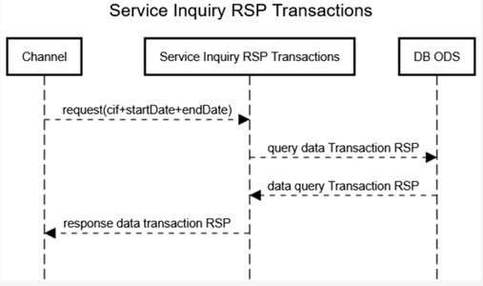

**2.2.3 Register Investor (ISL Maverick)**

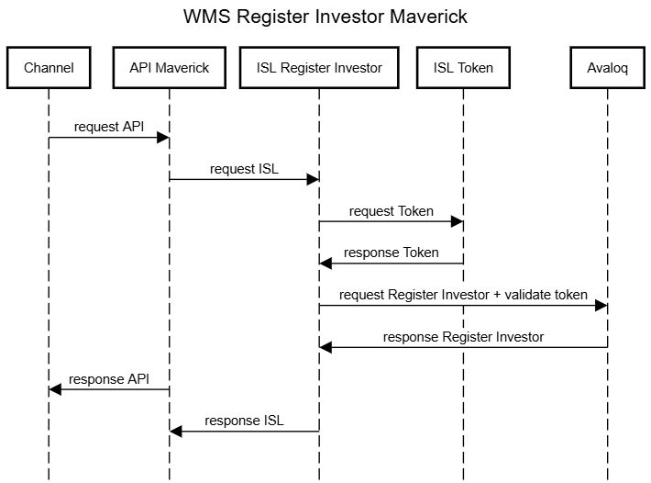

**2.2.4 Recurring Transaction (ISL Maverick)**

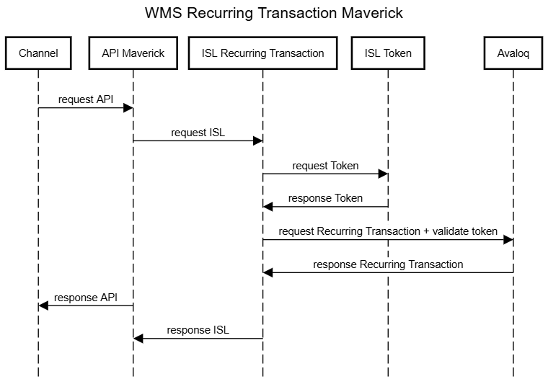

**2.2.5 Portfolio Details Bonds (ISL Maverick)**

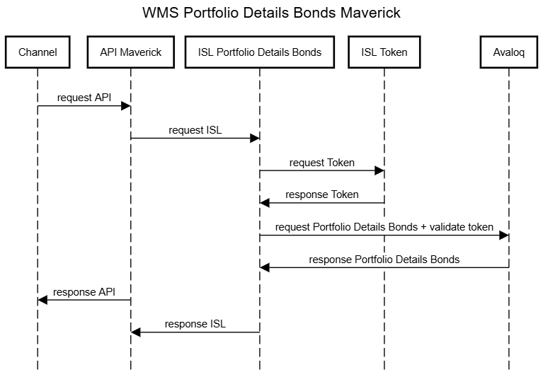

**2.2.6 Redeemable (Orders Early Redemption based on SID Investor)**

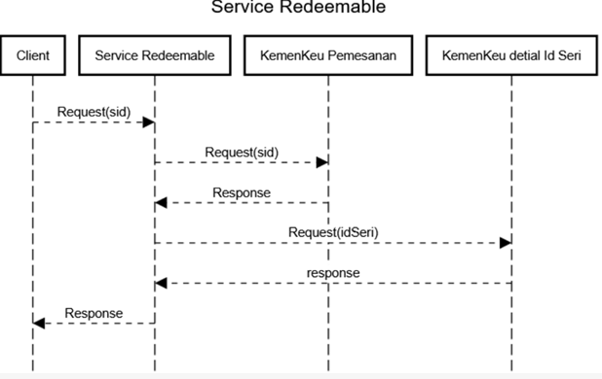

**2.2.7 Investor Risk Profile Registration**

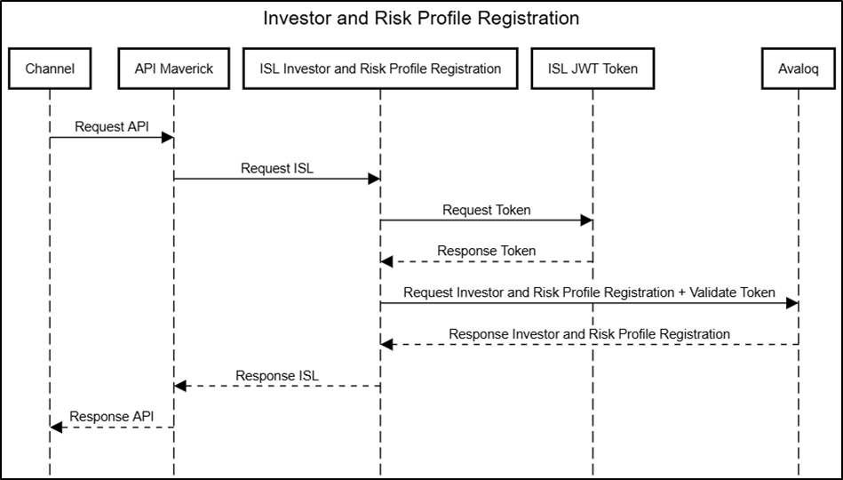

**2.2.8 Add Investor Securities Account**

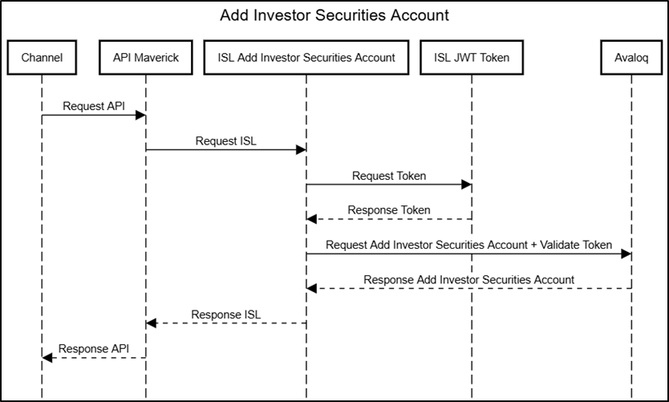

**2.2.9 Change Investor Securities Account**

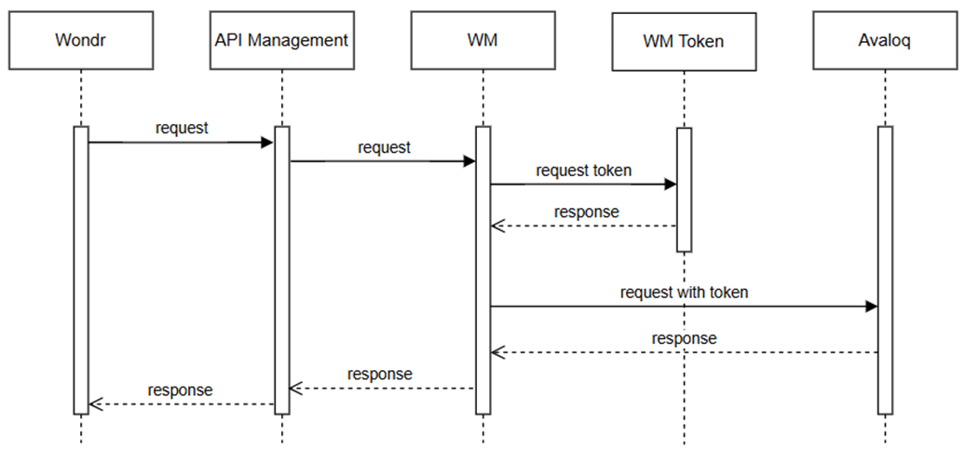

**2.2.10 Search (Customer Inquiry)**



**2.2.11 Quota ID (Quota Investor by Series)**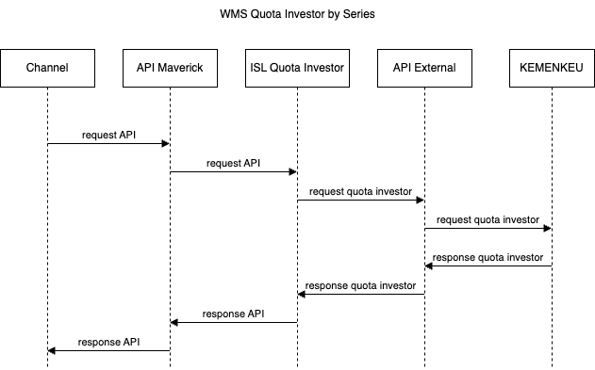

**2.2.12 Quota Investors based SID ID**

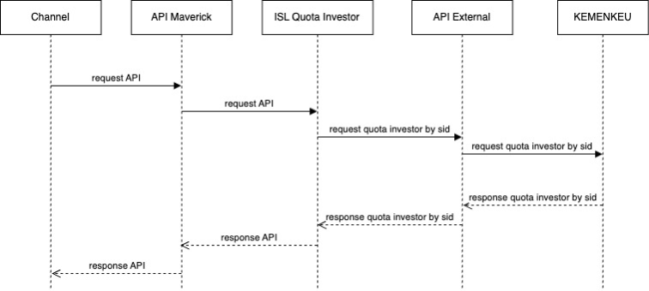

**2.2.13 Seri Redeem ID**

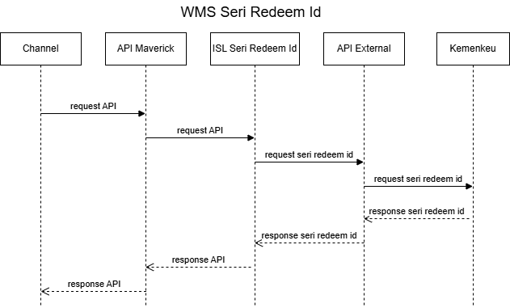

**2.2.14 Inquiry SID**

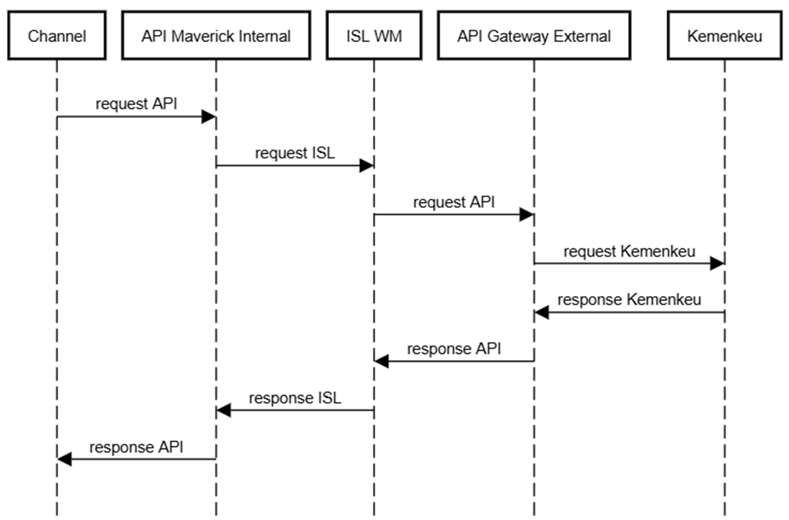

**2.2.15 Token Custom API**

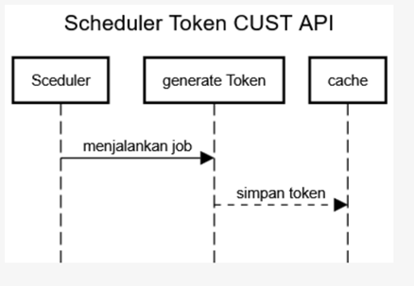

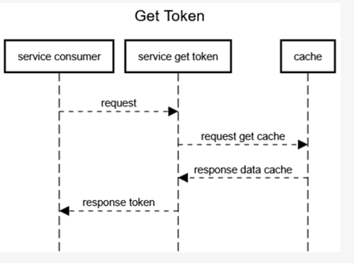

**2.2.16 Mapping-data-transaction-history**

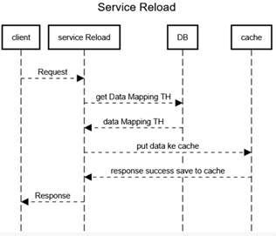

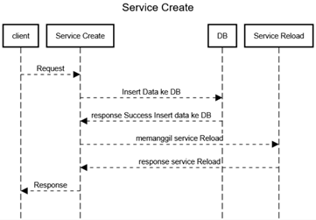

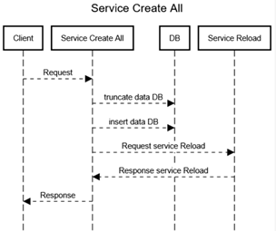

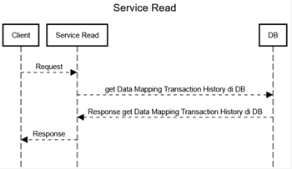

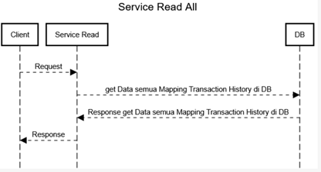

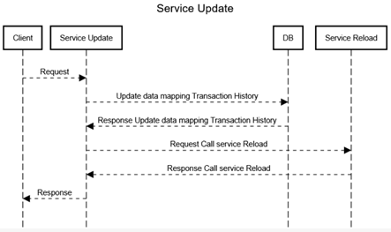

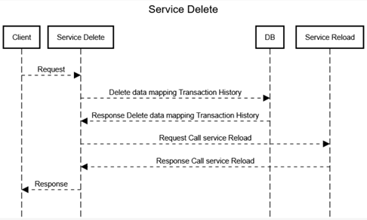

**2.2.17 Service List Ongoing RSP**

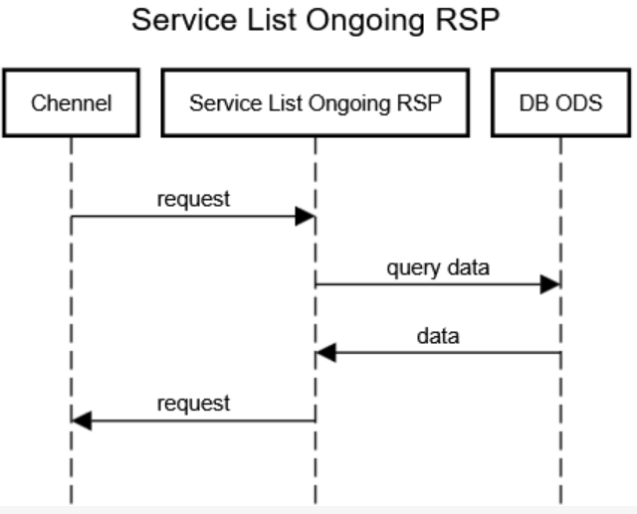

**3. Technical Stack**

* **Software**: Web Method Integration Server
* **Database**: Oracle *(Inquiry RSP Transactions)*
* **Caching**: Terracotta
* **Logging**: Elastic

**4. Data Management**

**4.1 Inquiry RSP Transactions (ISL Maverick)**

DB Oracle ODS

**AVL_TRANSACTION_FUND**

|  |  |  |
| --- | --- | --- |
| **Column Name** | **Column No** | **Data Type** |
| ORDER_NO | 1 | NUMBER |
| ORDER_STATUS | 2 | VARCHAR2(50) |
| ORDER_TYPE | 3 | VARCHAR2(50) |
| MEDIUM | 4 | VARCHAR2(50) |
| ORDERED_BY | 5 | VARCHAR2(100) |
| RSP_CONTRACT_NO | 6 | VARCHAR2(50) |
| ORDER_DATE | 7 | TIMESTAMP |
| TRADE_DATE | 8 | VARCHAR2(10) |
| VALUE_DATE | 9 | VARCHAR2(10) |
| BRANCH_CODE | 10 | VARCHAR2(10) |
| INPUTTER | 11 | VARCHAR2(10) |
| SALES_REPRESENTATIVE | 12 | VARCHAR2(10) |
| BP_CIF | 13 | VARCHAR2(20) |
| CONTAINER_ID | 14 | VARCHAR2(20) |
| BNI_ACCOUNT_NUMBER | 15 | VARCHAR2(20) |
| CUSTODIAN_CONTAINER_ID | 16 | VARCHAR2(50) |
| POSITION_ID | 17 | NUMBER |
| ASSET_CODE | 18 | VARCHAR2(50) |
| QUANTITY | 19 | NUMBER |
| EXECUTION_PRICE | 20 | NUMBER(18,2) |
| TRADING_CCY | 21 | VARCHAR2(10) |
| GROSS | 22 | NUMBER(18,2) |
| SUBSCRIPTION_FEE | 23 | NUMBER(18,2) |
| REDEMPTION_FEE | 24 | NUMBER(18,2) |
| SWITCHING_FEE | 25 | NUMBER(18,2) |
| ADMIN_FEE | 26 | NUMBER(18,2) |
| NET | 27 | NUMBER(18,2) |
| TIMESTAMP | 28 | TIMESTAMP |
| SUBSTITUTION_ORDER_NO | 29 | VARCHAR2(50) |
| SUBSTITUTION_ORDER_STATUS | 30 | VARCHAR2(50) |
| SUBSTITUTION_EXECUTION_PRICE | 31 | NUMBER(18,2) |
| SUBSTITUTION_QUANTITY | 32 | NUMBER |
| SUBSTITUTION_TIMESTAMP | 33 | TIMESTAMP |
| SWITCH_SUBSCRIPTION_ORDER_NO | 34 | VARCHAR2(50) |
| SWITCH_SUBSCRIPTION_ORDER_STATUS | 35 | VARCHAR2(50) |
| SWITCH_SUBSCRIPTION_ASSET_CODE | 36 | VARCHAR2(50) |
| SWITCH_SUBSCRIPTION_GROSS | 37 | NUMBER(18,2) |
| SWITCH_SUBSCRIPTION_NET | 38 | NUMBER(18,2) |
| SWITCH_SUBSCRIPTION_EXEC_PRICE | 39 | NUMBER(18,2) |
| SWITCH_SUBSCRIPTION_QUANTITY | 40 | NUMBER |
| SWITCH_SUBSCRIPTION_TIMESTAMP | 41 | TIMESTAMP |
| LOAD_TIMESTAMP | 42 | TIMESTAMP |
| ETL_FLAG | 43 | NUMBER(1,0) |
| SRC_STM_ID | 44 | VARCHAR2(8) |
| MSR_PRD_ID | 45 | VARCHAR2(8) |
| ROW_NO | 46 | NUMBER(38,0) |
| SRCTBLPRDID | 47 | VARCHAR2(60) |

**AVL_ASSET_FUND**

|  |  |  |
| --- | --- | --- |
| **Column Name** | **#** | **Type** |
| AVALOQ_ID | 1 | VARCHAR2(100) |
| UT_CODE | 2 | VARCHAR2(50) |
| INTERNAL_ID | 3 | VARCHAR2(50) |
| REFERENCE | 4 | VARCHAR2(50) |
| LEGACY_KEY | 5 | NUMBER(38,0) |
| INFOVESTA_CODE | 6 | VARCHAR2(200) |
| NAME | 7 | VARCHAR2(255) |
| ASSET_TYPE | 8 | VARCHAR2(255) |
| ASSET_GROUP | 9 | VARCHAR2(50) |
| CUSTOMER_SEGMENT | 10 | VARCHAR2(255) |
| OPEN_DATE | 11 | DATE |
| CLOSE_DATE | 12 | DATE |
| STATUS | 13 | VARCHAR2(50) |
| ISSUER | 14 | VARCHAR2(100) |
| CUSTODIAN_BANK | 15 | VARCHAR2(100) |
| ASSET_DOMICILE | 16 | VARCHAR2(50) |
| DENOMINATED_CCY | 17 | VARCHAR2(10) |
| ISSUE_PRICE | 18 | NUMBER(15,4) |
| ISSUE_DATE | 19 | DATE |
| MATURITY_DATE | 20 | DATE |
| PAR_VALUE | 21 | NUMBER(38,0) |
| TRADE_UNIT | 22 | NUMBER(10,4) |
| TRADE_UNIT_MD | 23 | NUMBER(10,2) |
| ROUND_LOT | 24 | NUMBER(38,0) |
| ROUND_LOT_MD | 25 | NUMBER(38,0) |
| ENABLE_RSP | 26 | VARCHAR2(50) |
| ALLOW_SUBSCRIPTION | 27 | VARCHAR2(50) |
| ALLOW_REDEMPTION | 28 | VARCHAR2(50) |
| ALLOW_SWITCHING | 29 | VARCHAR2(50) |
| INVESTMENT_CATEGORY | 30 | VARCHAR2(50) |
| MAX_HOLDING | 31 | NUMBER(38,0) |
| MAX_REDEMPTION | 32 | NUMBER(38,0) |
| MIN_INIT_SUBSCRIPTION | 33 | NUMBER(38,0) |
| MAX_INIT_SUBSCRIPTION | 34 | NUMBER(38,0) |
| MAX_INVESTORS | 35 | NUMBER(38,0) |
| QUOTA_IN_UNIT | 36 | NUMBER(38,0) |
| QUOTA_IN_AMT | 37 | NUMBER(38,0) |
| SUBSCRIPTION_BRANCH_MIN_AMT | 38 | NUMBER(38,0) |
| SUBSCRIPTION_BRANCH_MAX_AMT | 39 | NUMBER(38,0) |
| SUBSCRIPTION_MB_MIN_AMT | 40 | NUMBER(38,0) |
| SUBSCRIPTION_MB_MAX_AMT | 41 | NUMBER(38,0) |
| REDEMPTION_BRANCH_MIN_AMT | 42 | NUMBER(38,0) |
| REDEMPTION_BRANCH_MAX_AMT | 43 | NUMBER(38,0) |
| REDEMPTION_BRANCH_MIN_QTY | 44 | NUMBER(38,0) |
| REDEMPTION_BRANCH_MAX_QTY | 45 | NUMBER(38,0) |
| REDEMPTION_BRANCH_MIN_BALANCE_AFTER_TRADE | 46 | NUMBER(38,0) |
| REDEMPTION_MB_MIN_AMT | 47 | NUMBER(38,0) |
| REDEMPTION_MB_MAX_AMT | 48 | NUMBER(38,0) |
| REDEMPTION_MB_MIN_QTY | 49 | NUMBER(38,0) |
| REDEMPTION_MB_MAX_QTY | 50 | NUMBER(38,0) |
| REDEMPTION_MB_MIN_BALANCE_AFTER_TRADE | 51 | NUMBER(38,0) |
| SWITCH_BRANCH_MIN_AMT | 52 | NUMBER(38,0) |
| SWITCH_BRANCH_MAX_AMT | 53 | NUMBER(38,0) |
| SWITCH_BRANCH_MIN_QTY | 54 | NUMBER(38,0) |
| SWITCH_BRANCH_MAX_QTY | 55 | NUMBER(38,0) |
| SWITCH_BRANCH_MIN_BALANCE_AFTER_TRADE | 56 | NUMBER(38,0) |
| SWITCH_MB_MIN_AMT | 57 | NUMBER(38,0) |
| SWITCH_MB_MAX_AMT | 58 | NUMBER(38,0) |
| SWITCH_MB_MIN_QTY | 59 | NUMBER(38,0) |
| SWITCH_MB_MAX_QTY | 60 | NUMBER(38,0) |
| SWITCH_MB_MIN_BALANCE_AFTER_TRADE | 61 | NUMBER(38,0) |
| MARKET | 62 | VARCHAR2(255) |
| IPO_PERIOD_FROM | 63 | DATE |
| IPO_PERIOD_TO | 64 | DATE |
| IPO_SETTLEMENT_DATE | 65 | DATE |
| PFM_CATEGORY | 66 | VARCHAR2(50) |
| PFM_CLASS | 67 | VARCHAR2(50) |
| PFM_MARKET | 68 | VARCHAR2(50) |
| PFM_RATING | 69 | VARCHAR2(50) |
| PRODUCT_KNOWLEDGE | 70 | VARCHAR2(100) |
| RISK_RATING | 71 | VARCHAR2(50) |
| PRODUCT_CATEGORY | 72 | VARCHAR2(50) |
| FUND_FACT_SHEET_URL | 73 | VARCHAR2(255) |
| PROSPECTUS_URL | 74 | VARCHAR2(255) |
| SYARIAH_STATUS | 75 | VARCHAR2(20) |
| LOAD_TIMESTAMP | 76 | TIMESTAMP |
| ETL_FLAG | 77 | NUMBER(1,0) |
| SRC_STM_ID | 78 | VARCHAR2(8) |
| MSR_PRD_ID | 79 | VARCHAR2(8) |
| ROW_NO | 80 | NUMBER(38,0) |
| SRCTBLPRDID | 81 | VARCHAR2(60) |

**4.2 Mapping-data-transaction-history**

DB Oracle Maverick

|  |  |  |
| --- | --- | --- |
| **Column Name** | **#** | **Type** |
| ODS_TRANSACTION_TYPE | 1 | VARCHAR2(255 CHAR) |
| ODS_SUBHEADER | 2 | VARCHAR2(255 CHAR) |
| MS_TRANSACTION_TYPE | 3 | VARCHAR2(255 CHAR) |
| CREATED_DATE | 4 | TIMESTAMP(6) |
| CREATED_BY | 5 | VARCHAR2(255 CHAR) |
| UPDATED_DATE | 6 | TIMESTAMP(6) |
| UPDATED_BY | 7 | VARCHAR2(255 CHAR) |
| MS_SUBHEADER | 8 | VARCHAR2(255 BYTE) |

**4.3 Other Services**

*there is no database used for other services*

**5. Deployment**

**5.1 Deployment Environment**

* **Environment**: Web Method Integration Server
* **Configuration**: refer to *Delivery Form* document for each CR

**5.2 Deployment Process**

refer to *Delivery Form* document for each CR

# DELIVERY APPROVAL

|  |  |  |
| --- | --- | --- |
| IT DEVELOPER NAME : TETTY ROMONDANG SINTA RIA / 821820 | **IT DEVELOPER (MGR)**  NAME : MELVILIUS WELBY / P062989 | **Pgs. DEPT HEAD OF RETAIL CHANNEL & SERVICES DELIVERY**  NAME : DIAN AMALIA PONGDATU / P043191 |